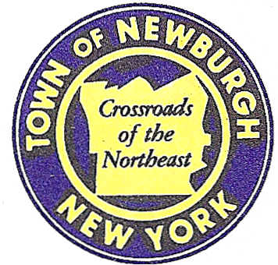

TOWN OF NEWBURGH
_______Crossroads of the Northeast __________________________
OLD TOWN HALL
308 GARDNERTOWN ROAD NEWBURGH, NEW YORK 12550

PLANNING BOARD
JOHN P. EWASUTYN, CHAIRMAN
TELEPHONE 845-564-7804
FAX 845-564-7802
E-MAIL: planningboard@townofnewburgh.org

PLANNING BOARD AGENDA

November 1st, 2018

*PLEASE NOTE: The Planning Board Meeting will start at 7:00 P.M. and all Applicants/Representatives
are to be present at that time. The Meeting will be held in the Meeting Room of Town Hall,
located at 1496 Route 300, Newburgh NY.*

- Fletcher Drive Subdivision-East Rock Cut Corp. (18-11) 4 LOT SUBDIVISION
Fletcher Drive
Section 93, Block 1, Lot 64.5
Zone: R-1
Rep: Maser Consulting, P.A./Justin Dates
555 Hudson Valley Ave. Suite 101
New Windsor, NY 12553

- 233 Quaker Street/Drivanos Two Family (18-19) INITIAL APPEARANCE
233 Quaker Street TWO FAMILY
Section 2, Block 1, Lot 15
Zone: AR
Rep: Michael Aiello, P.E., PLLC
Montgomery, NY 12549

- Shoppes at Newburgh (18-10) PUBLIC HEARING
Corner of Union Ave. & Orr Ave. AMENDED SITE PLAN
Section 96 , Block 1, Lot 6.2
Zone: IB
Rep: Langan Engineering
300 Kimball Drive
Parsipanny, NJ 07054

*WORK SESSION*
Project Readiness Discussion scheduled for 5:30 p.m. in the Meeting Room of
Town Hall on Thursday, November 1st, 2018.*

PLANNING BOARD BUSINESS
WORK SESSION

- Trinity Square (2006-53) Requesting a six month extension from November 1, 2018 to May 1, 2019.

- Animal Care Business-Proposed for 446 South Plank Rd: Discussion

.

*WORK SESSION*
Project Readiness Discussion scheduled for 5:3 0 p.m. in the Meeting Room of
Town Hall on Thursday, November 1st, 2018.*

